# INTRODUCTION

* 1. Overview
* A YouTuber is a type of social media influencer who uploads or creates videos on the American online video-sharing website YouTube, typically posting to their personal YouTube channel. The term was first used in the English language in 2006, and subsequently appeared in the 2006 Time Person of the Year issue.
* YouTube subscribers refer to the people or accounts that are subscribed to your channel. So whenever you upload a new video, your subscribers will be able to see it in their feeds. This makes your subscribers more likely to watch the videos you upload.
* Be sure that each video has a unique description; this makes it easier to find through search, and helps it stand out from similar videos.
* Identify 1-2 main words that describe your video and feature them prominently in both your description and title.
  1. Purpose
* Many viewers watch and like the content from start to end but don't subscribe. As a result, they don't get notifications or suggestions in the news feed whenever the same YouTuber uploads a video. Therefore, the main goal of YouTube subscribers is to increase upload reach and engagement
* YouTube content creators can start earning money from their videos once they reach 1,000 subscribers and 4,000 watch hours, but how much they make depends on several factors, including how much the advertiser pays (usually between $0.10 and $0.30 per view) and the number of views on the video.

1. **Problem Definition & Design Thinking**
   1. Empathy Map

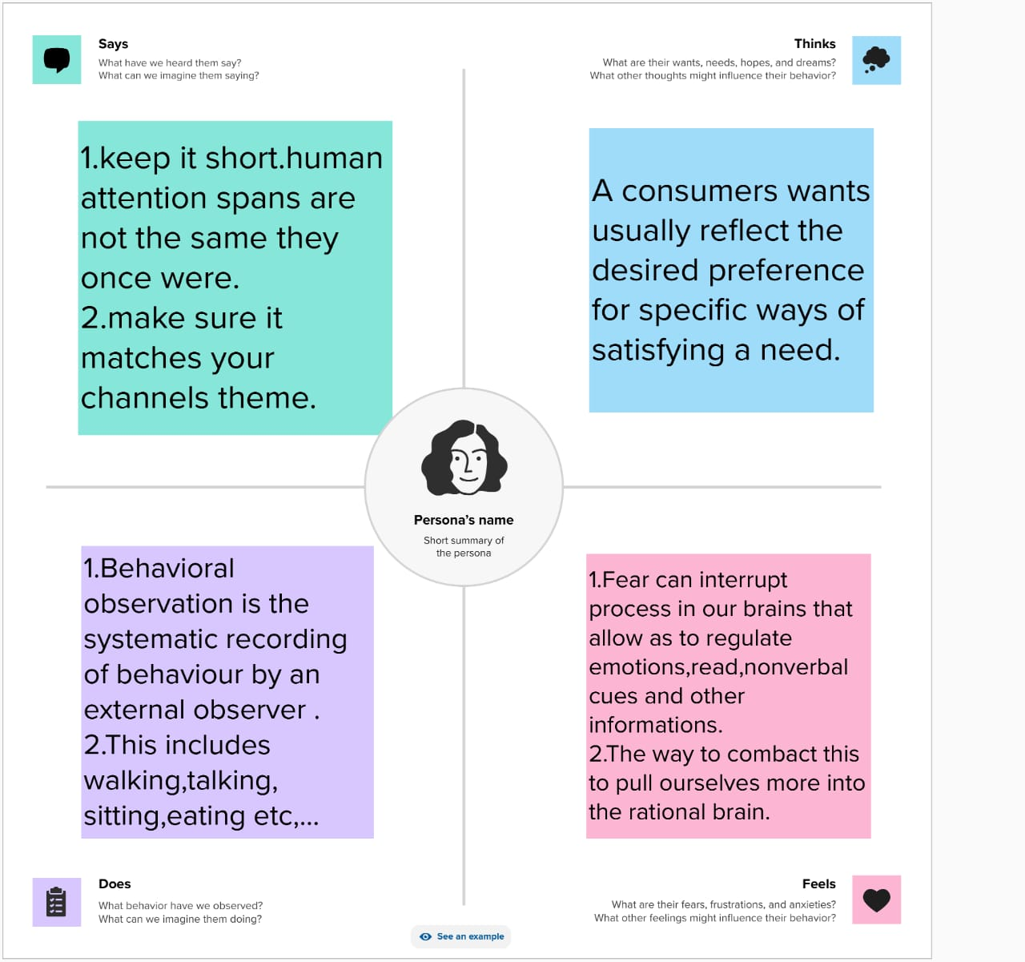

* 1. Ideation & Brainstorming Map

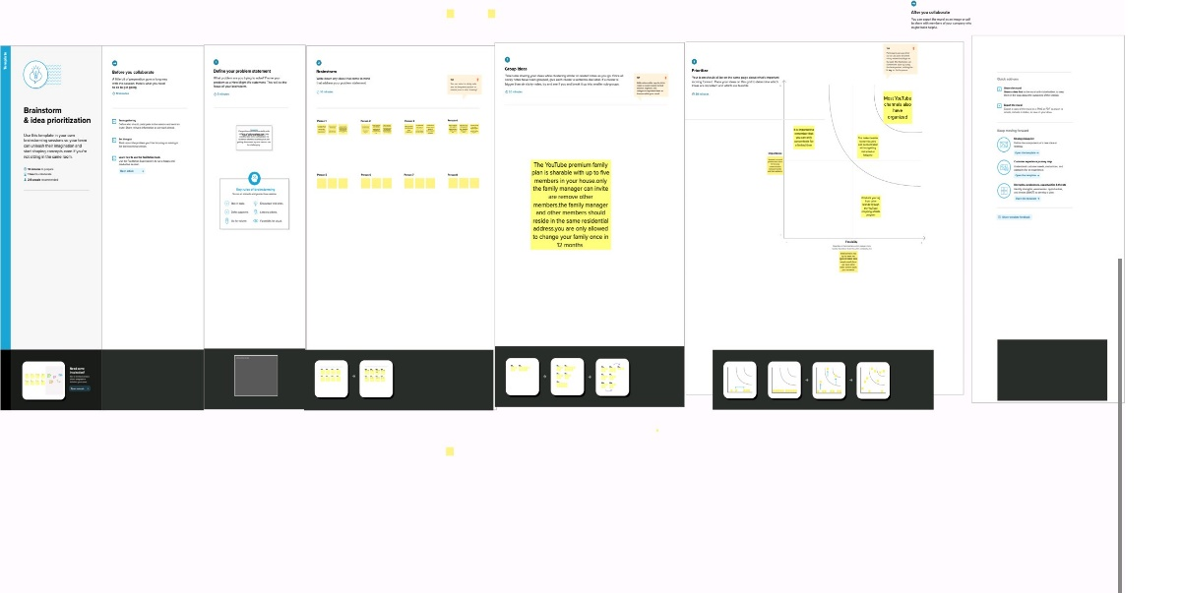

# RESULT

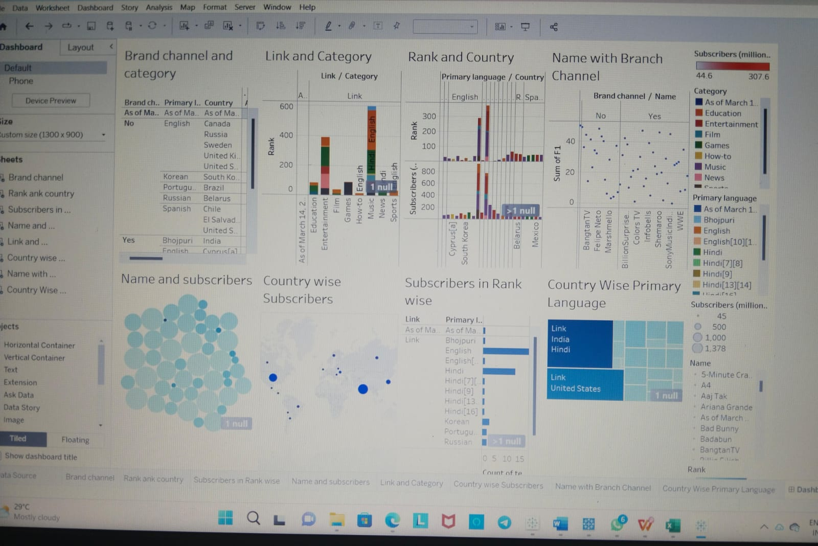

# ADVANTAGES

* After parties & live chat.
* Smart device integration.
* Smart downloads.
* Co-Watch with Google Meet.
* Special offers and early access to new features.

**DISADVANTAGES**

* Ads- a drawback of YouTube for the audience. ADVERTISEMENT. ...
* A lot of distraction. ADVERTISEMENT. ...
* Obscenity- one of the biggest drawbacks that YouTube has. The kind of content that is uploaded on YouTube is largely in control today. ...
* Defamation and Bullying. ...
* Making money isn't that easy**.**

# APPLICATIONS

# •Tube Mine: Get Free Subscribers, Views, and Likes For your Video & Channel. Tube Mine is the best application to help you boost your subscribers' number, grow your channel, and make your video content go viral.

* The best tool to grow your YouTube channel for most people is Tube Buddy or vid IQ. YouTube has quickly become one of the most important social channels on the planet. With video consumption trends rising at astronomical rates, the possibilities are endless for creators and business.

# CONCLUSION

* YouTube channel descriptions are short descriptions, shown on the About section of your YouTube channel that describe who you are, what type of content you create, and why people should watch it. Channel descriptions are generally three to four sentences long.

# FUTURE SCOPE

•YouTube will be putting more money into the features and experiences that will make YouTube a better platform.

•YouTube in India is Good as a fulltime career with endless amount of possibilities. but it requires research, hard work, dedication, consistency etc., to be a successful youtuber.

# APPENDIX

1. Source Code

